

**NILE UNIVERSITY**

**Skin Diseases Image Detector Application**

**By:**

Mennatullah Mahmoud 18101713

Omnia Saeed 18102396

Menna Abdelsattar 18101590

Youmna Ramadan 18101142

Submitted in partial fulfillment of the requirements for Biomedical Acquisition Project

January 19, 2021

**Table of Contents**

Abstract 3

Introduction 4

Literature Review 7

Dataset 7

Deep Learning Algorithm 8

Flutter platform 9

Methodology 10

Dataset 10

Data preparation 10

Sample Selection 11

Training Algorithm 12

Mobile Application 14

Results and Discussion 17

Google Cloud Platform 17

Mobile Application 18

Conclusion 20

References 21

# Abstract

Skin diseases are more common than other diseases, they may be caused by fungal infection, bacterial, allergy or viruses. The advancement of lasers and photonic based medical technology has made it possible to diagnose the skin diseases much more quickly and accurately. But the cost of such diagnosis is still limited and very expensive. So, image processing techniques help to build automated screening system for dermatology at an initial stage. The extraction of features plays a key role in helping to classify skin diseases. Computer vision has a role in the detection of skin diseases in a variety of techniques. We proposed an image processing-based method to detect skin diseases where we mainly depend on Google Cloud Platform (GCP) to make our machine learning model. This method takes the digital image of the disease affecting any skin area, then use image analysis to identify the type of disease. The approach works on the inputs of a color image. Then resize the image to extract features using pretrained convolutional neural network. Additionally, we build an app using flutter and dart language to help using our approach anywhere. Finally, you can get the results either by uploading the image on the platform itself or by using a python client to integrate the model with our application. Our proposed approach is simple, fast and does not require expensive equipment other than a camera and smart phone to download our app and upload the picture. The system successfully detects 8 different types of skin diseases with an accuracy rate of 80%.

# Introduction

Composed of epidermis, dermis, and subcutaneous tissues, skin is the largest organ of human body, containing blood vessels, lymphatic vessels, nerves, and muscles, which can perspire, perceive the external temperature, and protect the body. Covering the entire body, the skin can protect multiple tissues and organs in the body from external invasions including artificial skin damage, chemical damage, adventitious viruses, and individuals’ immune system. Besides, skin can also avoid the loss of lipids together with water within epidermis and dermis so that skin barrier function can be stabilized [1]. Epidermis, being the outermost skin layer, forms a waterproof and protective sheath around the body’s surface. The dermis, found beneath the epidermis, comprises of connective tissues and protects the body from stress and strain. A basement membrane tightly joins the dermis with the epidermis. The hypodermis, also called subcutaneous tissue, is not actually a part of the skin and lies below the dermis. It attaches the skin to the underlying bone and muscle and also supplies blood vessels and nerves to it [2]. In spite of defense and barrier function, skin is not indestructible in that skin tends to be constantly influenced by a variety of external and genetic factors. Skin diseases are common than other diseases, Skin diseases may be caused by fungal infection, bacteria, allergy, or viruses, etc. A skin disease may change texture or color of the skin. In general, skin diseases are chronic, infectious and sometimes may develop into skin cancer. Recent researchers have found the availability of cures for these diseases if they are detected in the early stages. Therefore, skin diseases must be diagnosis early to reduce their development and spread. Skin diseases are primarily diagnosed visually, beginning with an initial clinical screening and followed potentially by dermoscopic analysis. To ascertain what type of skin disease a person has, they must visit a dermatologist [3]. Therefore, diagnosis and treatment of a skin disease takes longer time and causes financial and physical cost to the patient. In general, most of the common people do not know the type and stage of a skin disease. Some of the skin diseases show symptoms several months later, causing the disease to develop and grow further. So, identifying the infected area of skin and detecting the type of disease is useful for early awareness. With the increase in medical technology the concept of computer being used for the diagnosis of skin diseases has been around recently. The most prevalent technology which is being used for the prediction is Artificial Intelligence using Machine Learning. Artificial Intelligence uses learning methods to learn about the images to predict the diseases based upon the common patterns. The machine interprets the images and its slices and processes the image and predicts.

Machine Learning is that branch of computer studies that gives the potentiality to the computer to grasp without being characteristically programmed. Machine learning is employed in a wide range of computing functions where building and designing specific algorithms with better performances is difficult or impractical. Machine Learning is also firmly attached to computational statistics which makes prediction through computers easier and feasible. In commercial terms Predictive Analysis is machine learning used to design multiple algorithms and models that greatly helps the process of prediction. Here the machine learns itself and divide the data provided into the levels of prediction and in a very short period of time gives the accurate results.

In this paper, a detection application is proposed which enables the users to detect and recognize skin disease. Detection application system is a system used for detecting whether a disease is present or not, and then classifying the type of disease, if present. The classification is based on decisions taken using the features extracted through the feature extraction methods. In order to identify whether a disease is present or not, the system must be trained to recognize normal conditions of system activity. There are two main phases for this purpose: training phase (building a profile using data about a particular disease) and testing phase (comparing the current image data with the trained image data). So, our proposed approach is simple, fast and does not require expensive equipment's other than a mobile and camera.

# Literature Review

In biomedical informatics field, research has been done on using image-based artificial intelligence diagnosis systems to help early detection of certain diseases, especially skin diseases. Some studies used deep neural networks to develop and modify image classification techniques [4]. Many previous studies showed promising results for both the reliability and accuracy of computer-aided decision support. A subset of published articles examined the combination of human expertise and artificial intelligence. Nevertheless, we still need to better integrate human knowledge into artificial intelligence and to use artificial intelligence to extend human intelligence.

## Dataset

In our previous study, we used the “**Dermnet**” website (Skin Disease Atlas) to download datasets. The dataset is composed of many categories(diseases) while every category includes number of images of type jpg and PNG. The used diseases are: - (“Scarlet Fever”, “tinea”, “trauma”, “vitiligo”, “Warts plantar”, “white Superficial Onychomycosis”,” Xanthoma”, and “Measles”). **Scarlet fever** is a disease resulting from a group A streptococcus (group A strep) infection, the signs and symptoms include a sore throat, fever, headaches, swollen lymph nodes, and a characteristic rash. This characteristic rash has been denoted as "scarlatiniform," and it appears as a diffuse redness of the skin with small papules, or bumps, which resemble goosebumps. **Tinea** is the name of a group of diseases caused by a fungus. Types of tinea include ringworm, athlete's foot, and jock itch and their symptoms vary between a red skin rash that forms a ring around normal-looking skin, bald spots & burning rash in the groin area. **Vitiligo** is a long-term condition where pale white patches develop on the skin. It's caused by the lack of melanin, which is the pigment in the skin. **Warts plantar** are benign epithelial tumors generally caused by infection by human papillomavirus types 1, 2, 4, 60, or 63, occurring on the bottom of the foot or toes. Their color is typically similar to that of the skin. Small black dots often occur on the surface. They may result in pain with pressure such that walking is difficult. **White Superficial Onychomycosis** is a fungal infection of the nail. The most common symptom of fungal nail infection is the nail becoming thickened and discolored: white, black, yellow, or green, and as the infection progresses the nail can become brittle, with pieces breaking off. **Xanthoma** is a deposition of yellowish cholesterol-rich material that can appear anywhere in the body in various disease states. They are cutaneous manifestations of lipidosis in which lipids accumulate in large foam cells within the skin. Measles is a highly contagious infectious disease caused by measles virus. One of its symptoms is a red, flat rash which usually starts on the back of the ears and, after a few hours, spreads to the head and neck before spreading to cover most of the body, often causing itching.

## Deep Learning Algorithm

Compared to the traditional computation algorithms, deep learning algorithms are way more effective in disease detection and diagnosis. Deep learning involves the usage of large neural networks that have neurons connected to each other that have the ability to modify their hyper-parameters whenever updated new data comes in. It is the technology that makes the computer systems able to learn things themselves without explicit programming from the human side. Based on a set of methods ML automatically detects patterns in data, and then utilize the uncovered patterns to predict future data or enable decision making under uncertain conditions [5]. Additionally, there are three approaches to AI: symbolism (rule-based, such as IBM Watson), connectionism (network and connection-based, such as deep learning or artificial neural net), and Bayesian (based on the Bayesian theorem). The most representative characteristic of ML is that it is driven by data, and the decision process is accomplished with minimum interventions by a human. Thus, the program can learn by analyzing training data, and then make a prediction when new data is put in.

## Flutter platform

Flutter is an open-source UI software development kit created by Google. It is used to develop applications for Android, iOS, Linux, Mac, Windows, Google Fuchsia, and the web from a single codebase. The first version of Flutter was known as codename "Sky" and ran on the Android operating system. It was unveiled at the 2015 Dart developer summit, with the stated intention of being able to render consistently at 120 frames per second. The major components of Flutter include Dart platform, Flutter engine, Foundation library, Design-specific widgets. In our project, we will use the flutter platform and dart language to make a mobile application that will be used in diagnoses and works as a simple tool that any patient can deal with.

# Methodology

## Dataset

In our paper, we used the “Dermnet” website (Skin Disease Atlas) to download datasets. The dataset is composed of 8 categories of skin diseases, every category has a range of 20~30 images of type jpg and PNG. The dataset comes from a combination of public accessible dermatology repositories, color photo atlas of dermatology and taken manually. The diseases are: Tinea, white_Superficial_Onychonycosis, Vitilligo, Xanthoma, Warts_plantar, Measles, Trauma, Scarlet_Fever. We used this dataset in google cloud platform to train and test it.

## Data preparation

The dataset contains sets of images in jpeg extension some taken manually corresponding to the same skin lesion but from multiple viewpoint or multiple set of images acquired on the same person. Figure 1 show some example of images for 7 skin diseases.

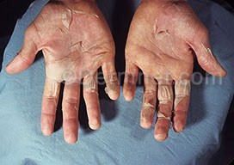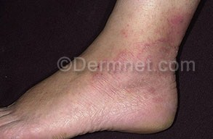 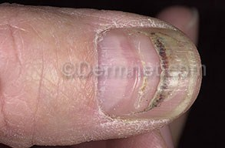  
 Scarlet Fever Tinea Trauma

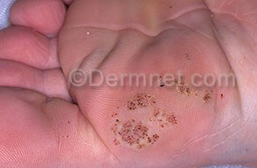 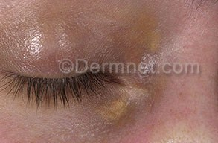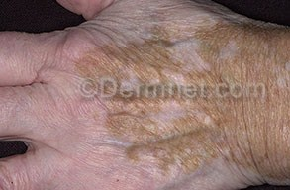 Vitilligo Warts Plantar Xanthoma

Figure 1: Sample Images of Dataset

## Sample Selection

The dataset is partition to train and test data for each category of skin disease. The trained data consists of 80% of the dataset while the tested data is 20%. The validation data was gathered either in the trained data or the tested data with the same number of images compared to tested data as shown in Table 1.

|  |  |  |  |  |
| --- | --- | --- | --- | --- |
| **Skin Disease** | **Number of images** | **Train Data** | **Test Data** | **Validation** |
| Trauma | 21 | 16 | 2 | 3 |
| Tinea | 21 | 16 | 2 | 3 |
| Scarlet Fever | 20 | 16 | 2 | 2 |
| white_Superficial_Onychonycosis | 13 | 13 | 1 | 2 |
| Vitilligo | 21 | 16 | 2 | 3 |
| Xanthoma | 14 | 11 | 1 | 2 |
| Warts_plantar | 20 | 16 | 2 | 2 |
| Measles | 30 | 24 | 3 | 3 |

Table 1: Dataset

## Training Algorithm

To make our machine learning model we used Google Cloud Platform (GCP) which is offered by Google and has a series of modular cloud services including machine learning which we used. We upload the images in folders according to the diseases to a cloud storage after making an account and enabling autoML. Then, we create a dataset in autoML vision to connect it to our cloud storage (and uploaded the images in the dataset in autoML as well).

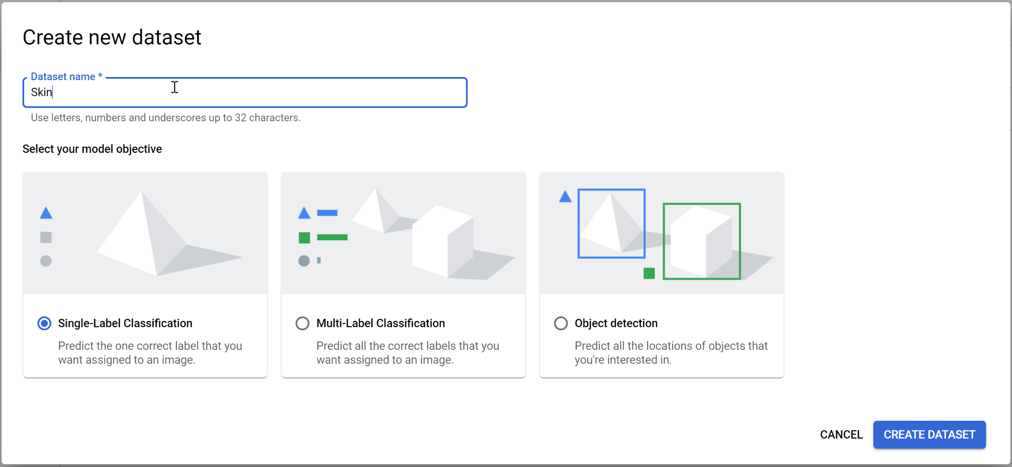

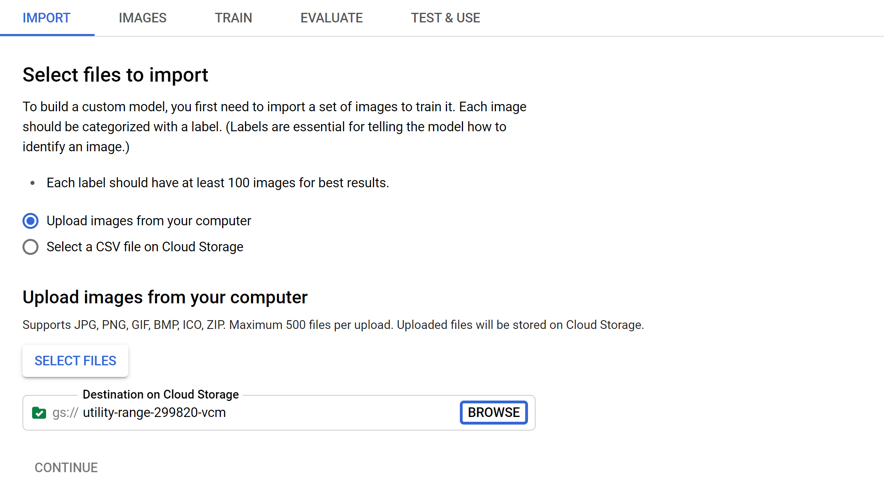

After the import is completed, the images must be all uploaded each is labeled with its disease.

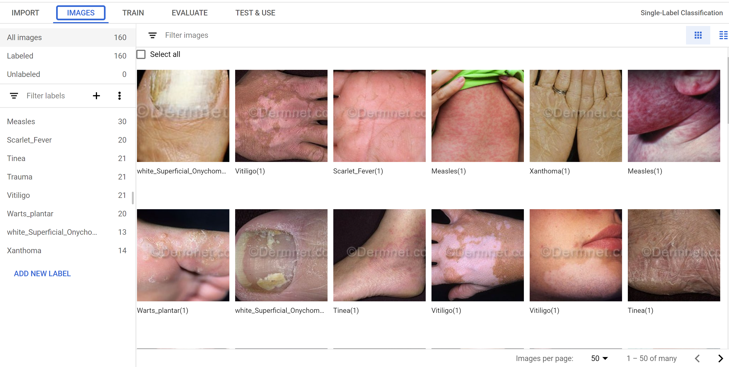Now, we are ready to train our model. The dataset is divided to 80% of the image for training the model, 10% for validation and the last 10% for testing. It took nearly 6 hours to be trained. After that, we have to deploy our model to generate a prediction on the model on data it hasn’t seen before. We can upload the image on the platform itself to get the prediction or use a python client to integrate the model with any other application and that what we will do. We will use the flutter platform and dart language to make the mobile application. It is a platform for both android and ios and it is another product from Google.

|  |  |  |  |
| --- | --- | --- | --- |
| Model | Weight size | Loading time (seconds) | Accuracy |
| Google cloud platform | 1.73 MB | 4 seconds | 84.21% |

Table 2: Evaluation of Google cloud platform Model by its Weight size, Loading time and Accuracy.

## Mobile Application

Our mobile application is made by flutter UI platform using dart language. It is composed of 3 main pages; the first page is a welcoming page and describes the function of the application as well, the second one which the image is uploaded in and the third page which outputs the result and the score to the user. As mentioned, we used python client to upload the image and get the prediction from the model in the google cloud platform using automl_v1beta1 library. Besides, in the python code, we used flask library to download the image on the local server to integrate the python code with the image taken in the flutter application. And here is snapshots from the application:

Page one:

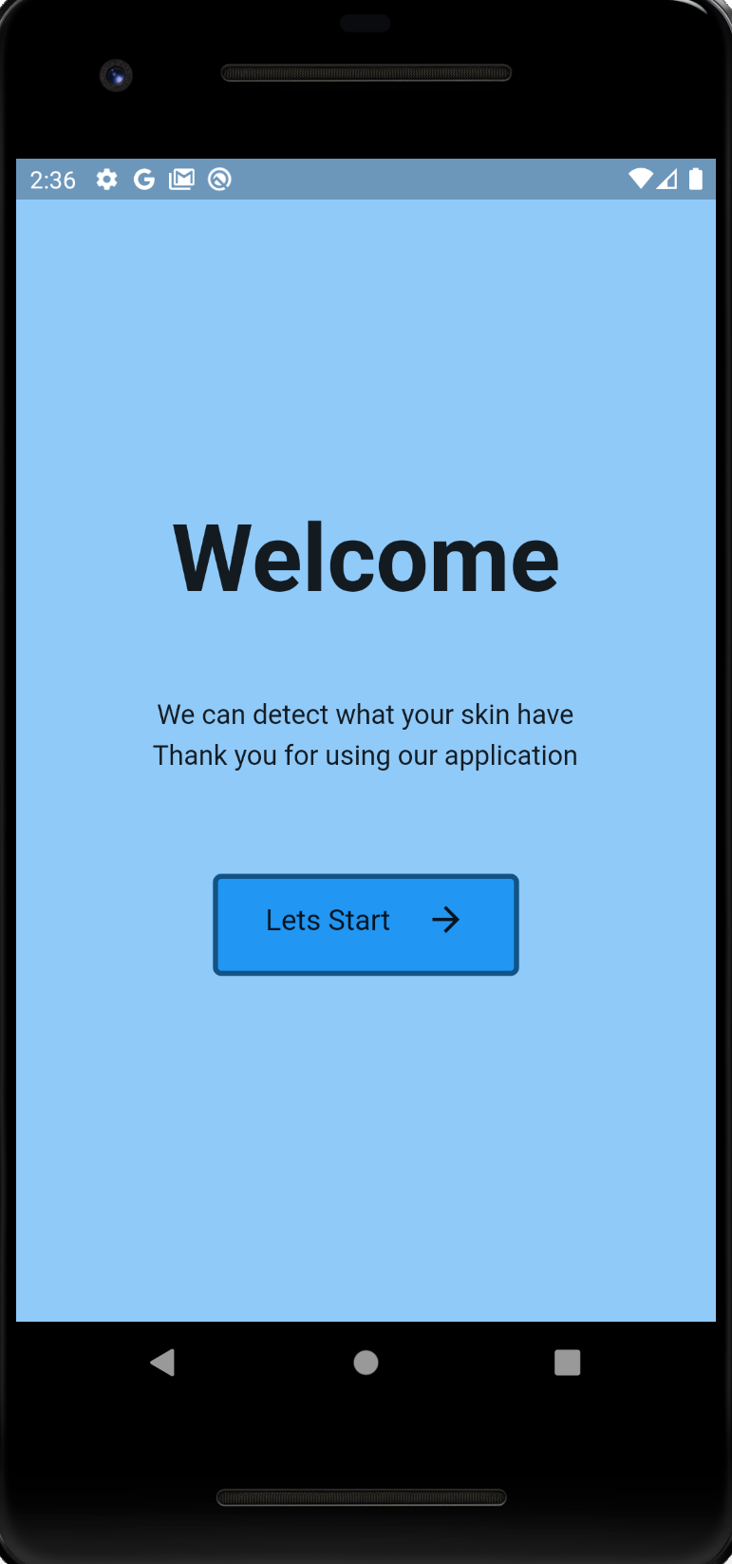

Page two:

We can either upload from the gallery or take a photo by the camera, here we uploaded an image (which we know it belongs to measles category to test our app), then we waited for the result button to appear.

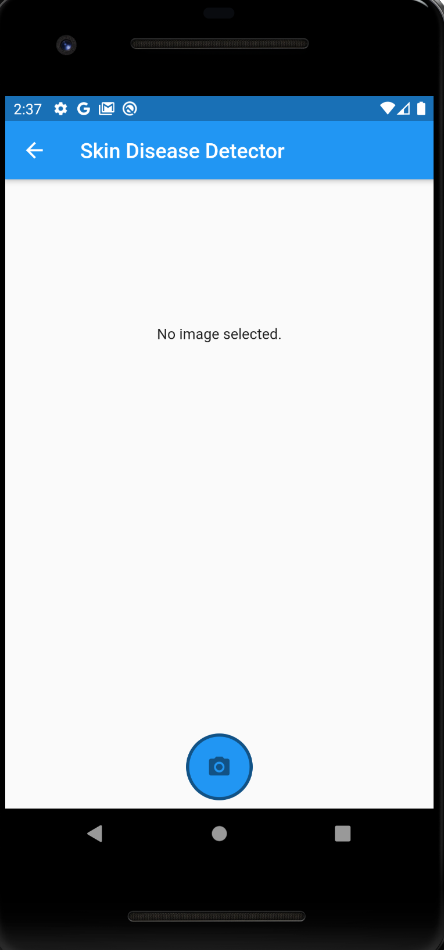 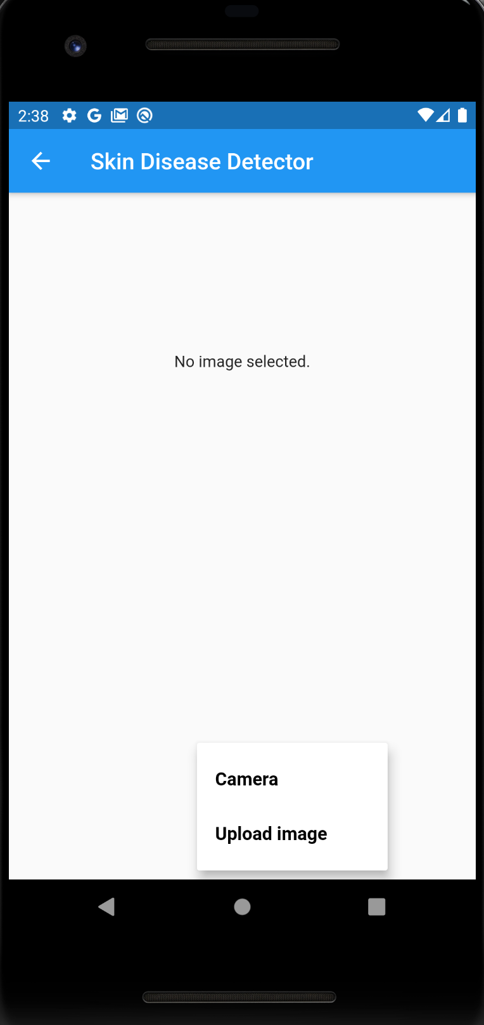 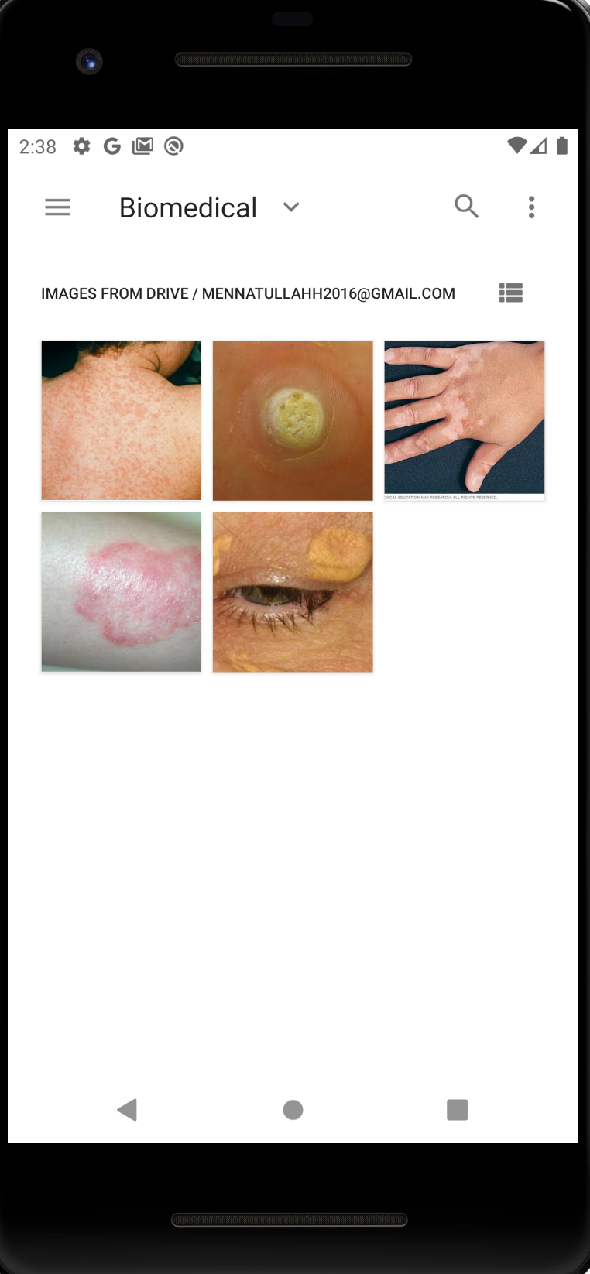 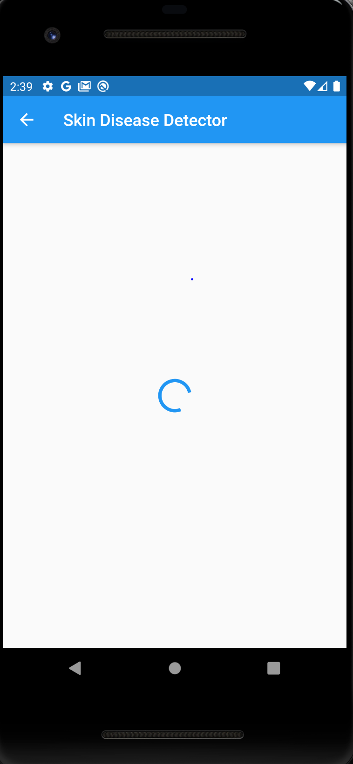 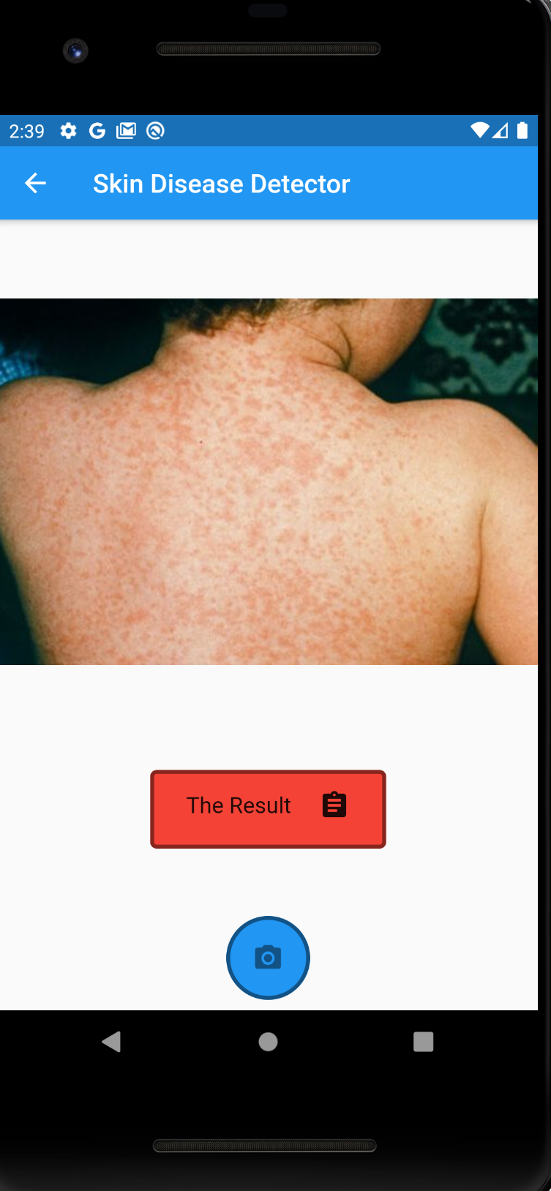

And the third page is the result which will be discussed later.

# Results and Discussion

## Google Cloud Platform

After training and deploying our model by the images uploaded, the result came with precision of 84%. Besides, there is a confusion matrix to clarify the outputs of the test images whether it is true or false.

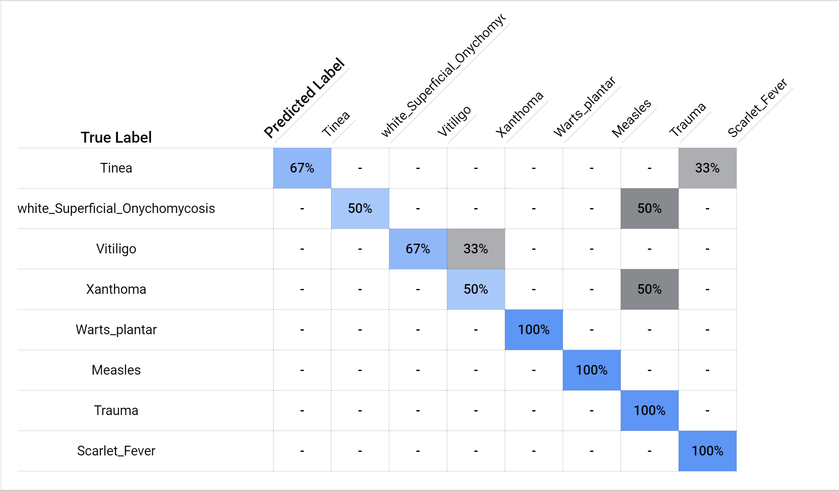

In the above image, as we see that for example the Tinea category test images has been predicted 67% true and 33% false as it is been predicted as scarlet fever. On the other hand, measles has been predicted all true. By calculating all of these results, the accuracy will be 84%. Besides, we can test our model directly from the google cloud platform by uploading our image. The result of the prediction will be printed and the score (the score is the probability of being predicted right) as well.

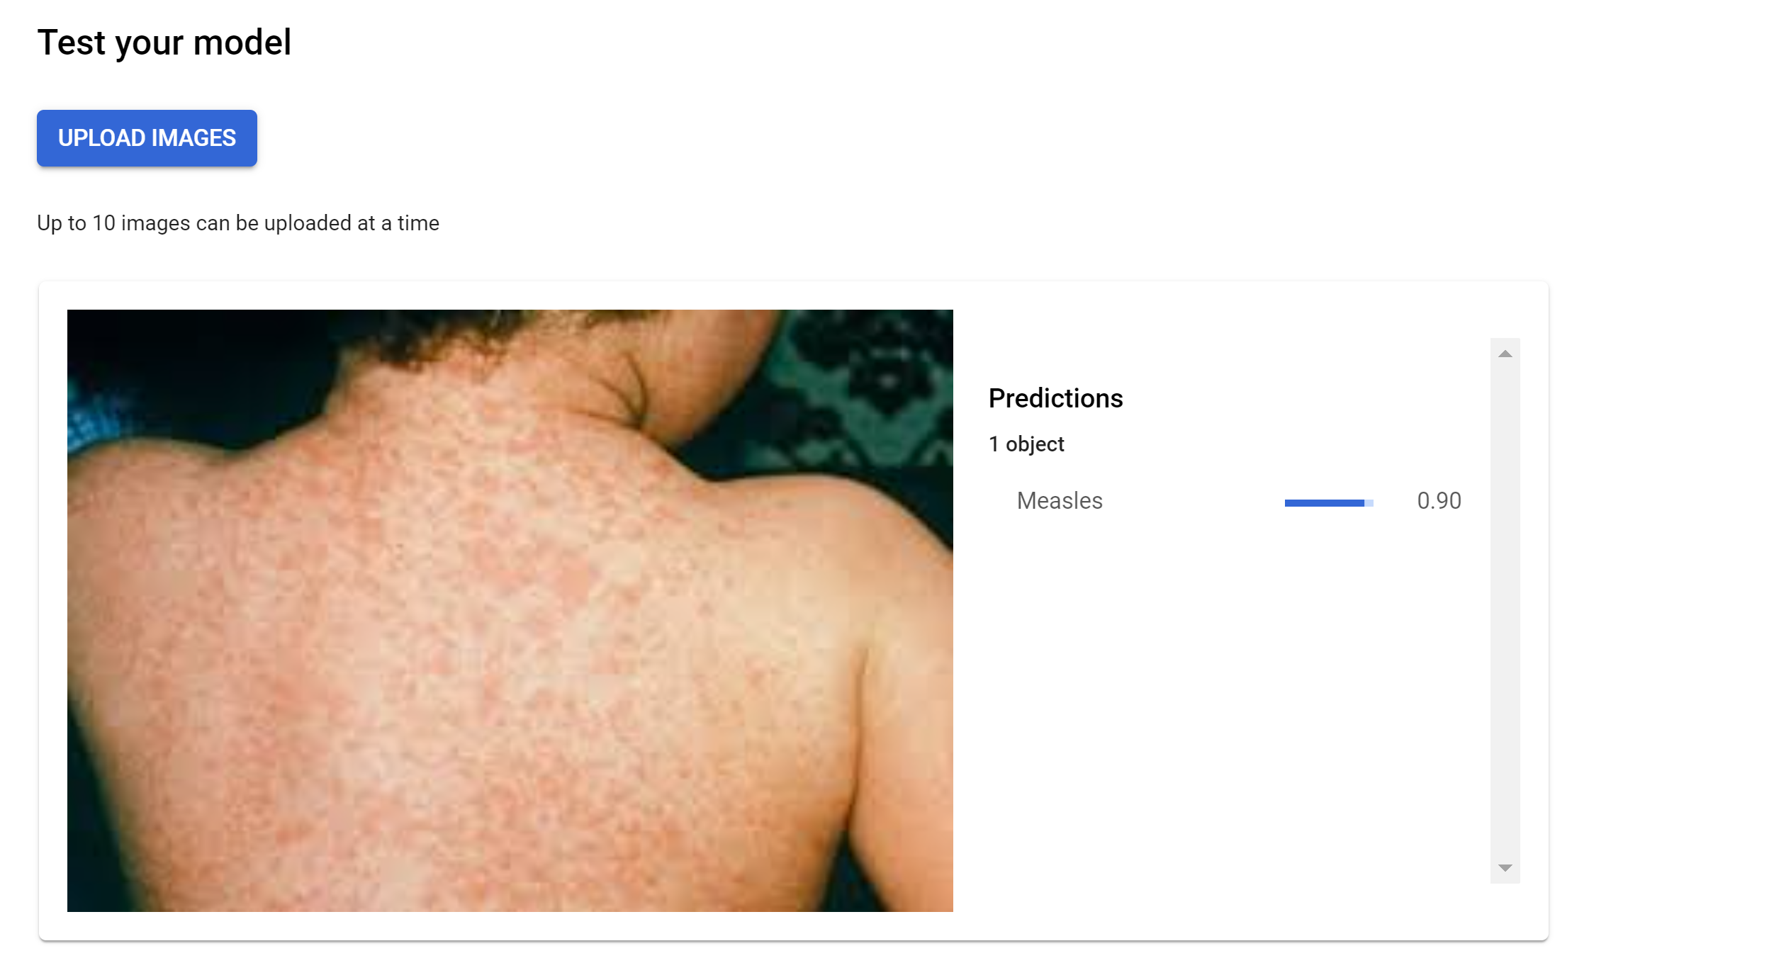

## Mobile Application

After pressing the result button in the mobile application, here comes the third page printing the output and the score below it.

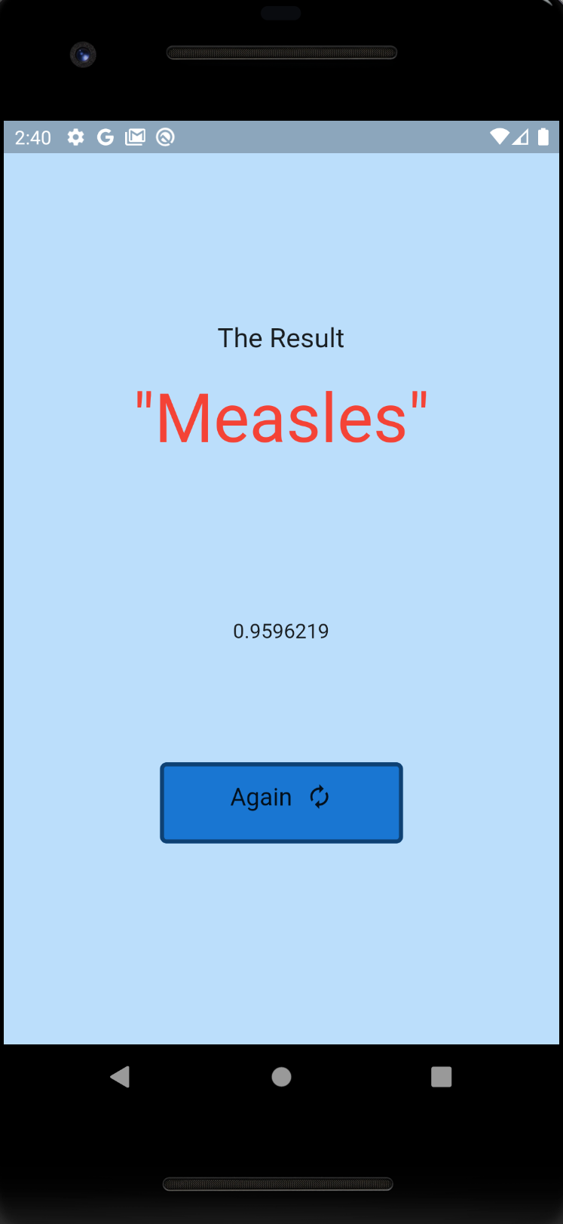

The user can press the “Again” button and can repeat all the previous steps and upload another image for another prediction.

# Conclusion

Detection of skin diseases is a very important step to reduce death rates, disease transmission and the development of the skin disease. Clinical procedures to detect skin diseases are very expensive and time-consuming. In this paper we mainly depend on Google Cloud Platform (GCP) to make our machine learning model. This method takes the digital image of the disease affecting any skin area, then use image analysis to identify the type of this disease. A Dataset of 8 diseases were used with an accuracy rate of 80%. In a subsequent study, we would like to explore the method of integrating more human knowledge into our algorithm based on the result analysis. We will also make the system more extensive and scalable by handling larger datasets and more diseases and image types.

# References

[1] Z. Hu and C. S. Yu, “Functional research and development of skin barrier,” Chinese Journal of Clinicians, vol. 7, no. 7, pp. 3101–3103, 2013.

[2] V. Pugazhenthi, Sagar Naik, Amruta Joshi, Shreya Manerkar, Vinita Nagvekar, *et al.* Skin Disease Detection and Classification. *International Journal of Advanced Engineering Research and Science (IJAERS)*, 2019, 6 (5), pp.396-400.

[3] M. J. Hajgude, A. Bhavsar, H. Achara, and N. Khubchandani, “Skin Disease Detection Using Image Processing with Data Mining and Deep Learning,” 04-Apr-2019. [Online]. Available: <https://www.irjet.net/archives/V6/i4/IRJET-V6I4954.pdf>

[4] Zhang, X., Wang, S., Liu, J. *et al.* Towards improving diagnosis of skin diseases by combining deep neural network and human knowledge. *BMC Med Inform Decis Mak* **18,**59 (2018). <https://doi.org/10.1186/s12911-018-0631-9>.

[5] Shrestha, A. , Mahmood,A .Review of Deep Learning Algorithms and Architectures.(2018). Retrieved from <https://www.researchgate.net/publication/332662087_Review_of_Deep_Learning_Algorithms_and_Architectures>